ULTRACEMCO 11500 CE
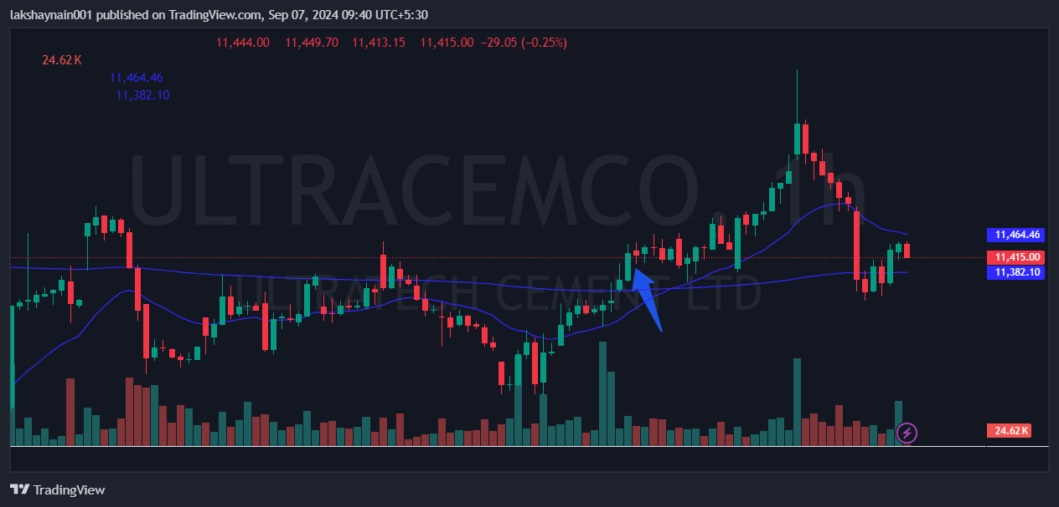

- Price bounced from 200HEMA
- Strong support of 20EMA
- Entry at strong bullish candle with volumes

