Gail sept 240CE
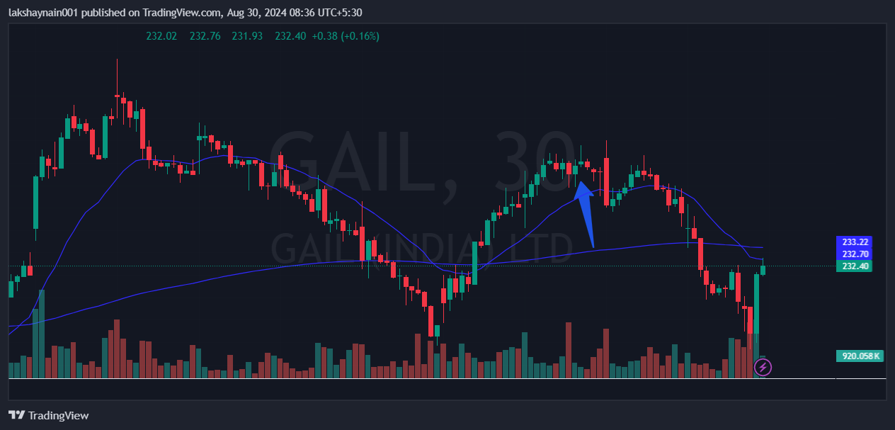
- Nifty energy index on move
- Broke week’s high
- Trading above 20EMA

