BTST Maruti 13000CE

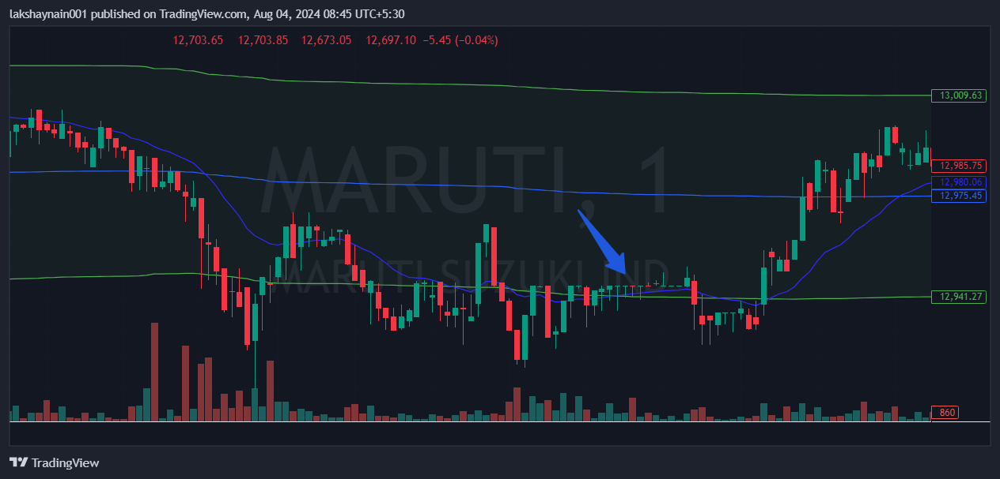

- Price opened gap up
- Price took support at 20EMA
- Nifty auto supports

