M&M 2950CE
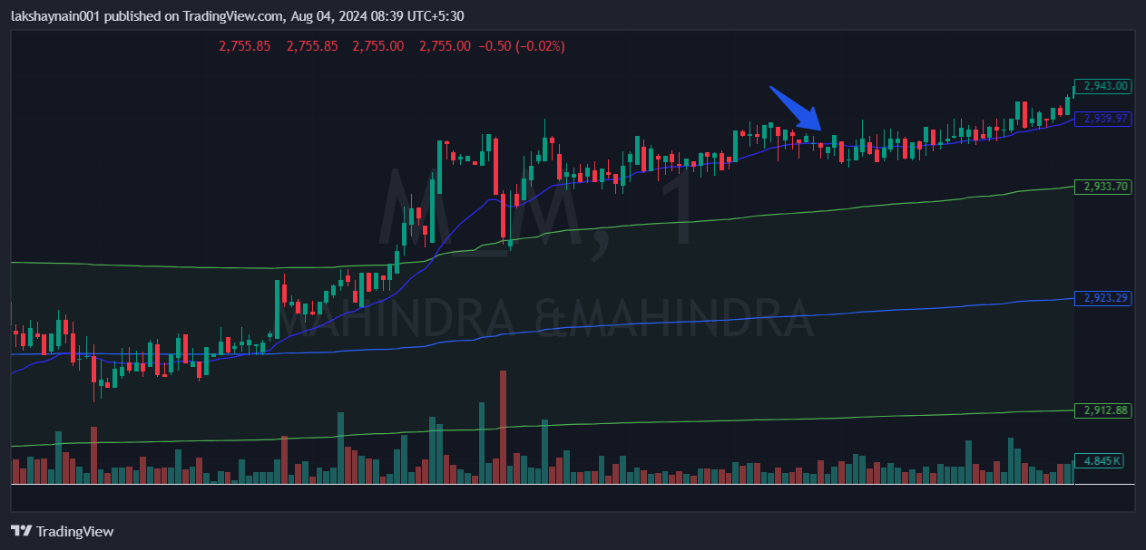
- Nifty auto on move
- Price at day high
- Price above vwap & taking support at 20EMA

