Bel 320CE
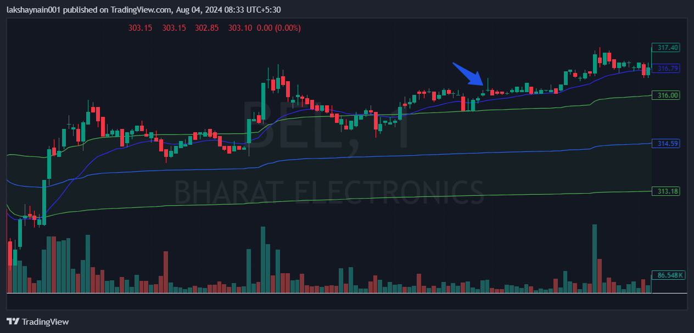
- Price gap up opened
- Price took support at 20EMA
- Price above vwap

