Abfrl 340CE
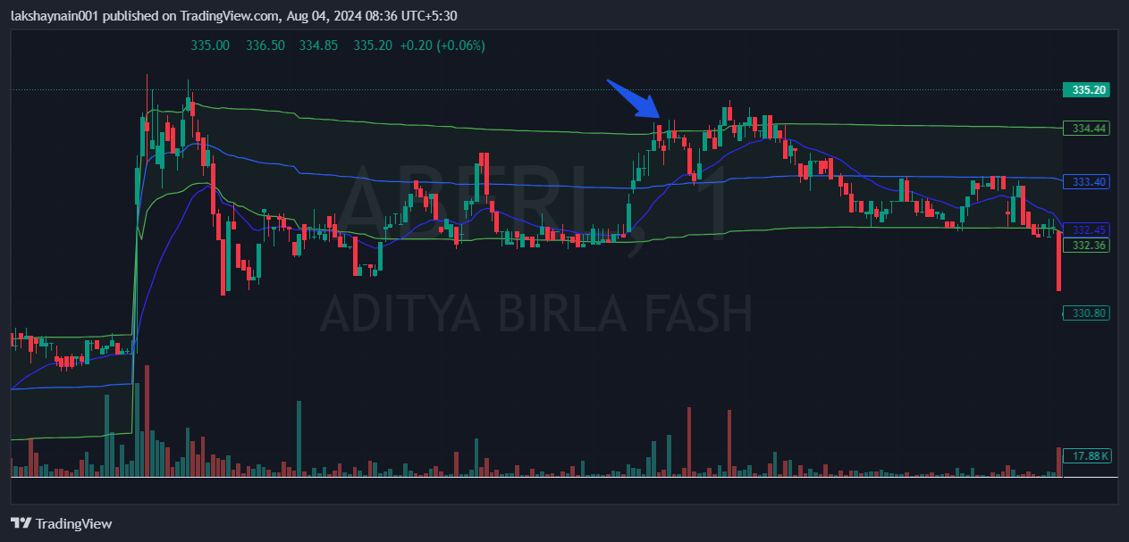
- Crossover vwap and 20EMA
- Price opened gap up
- Price took support at vwap

