Dabur 640CE
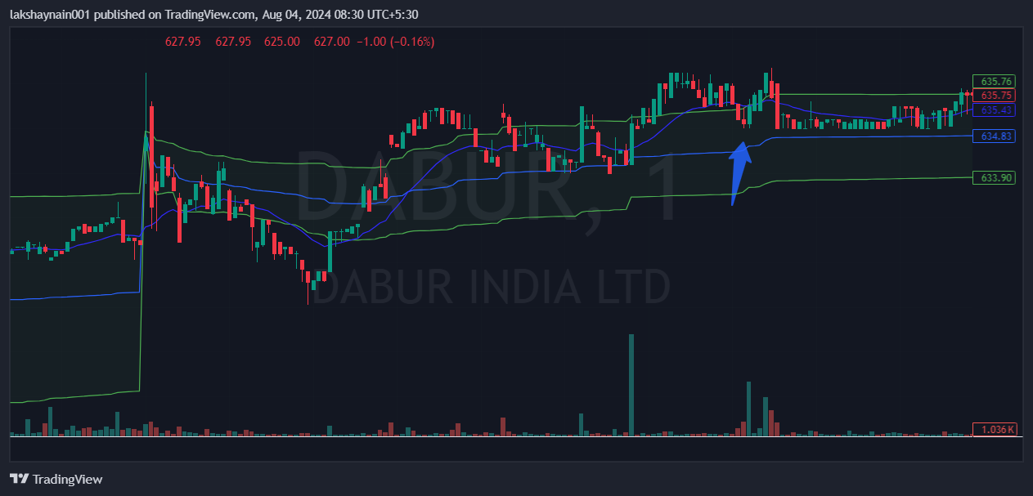
- Price opened gap up
- Price reversed from 20EMA
- Price above vwap

