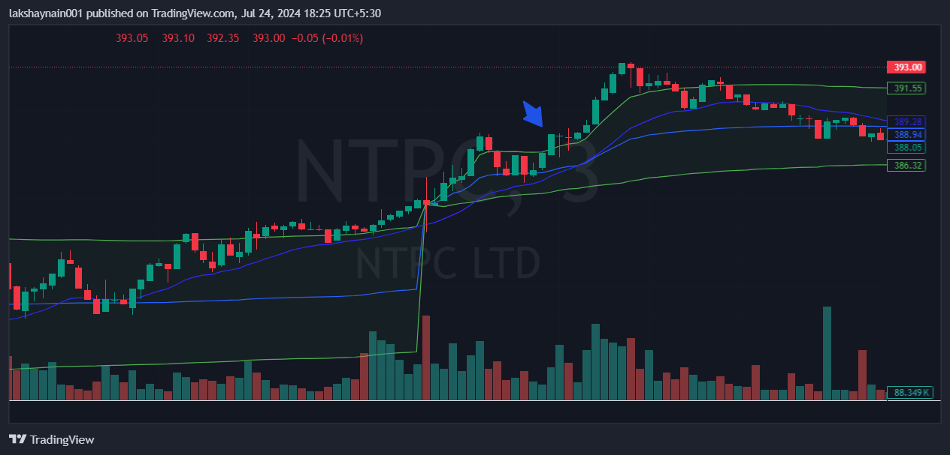
NTPC 390CE Aug
- Nifty energy up 1% up
- Price breaks day high with nice volumes
- Price above 20EMA and vwap

