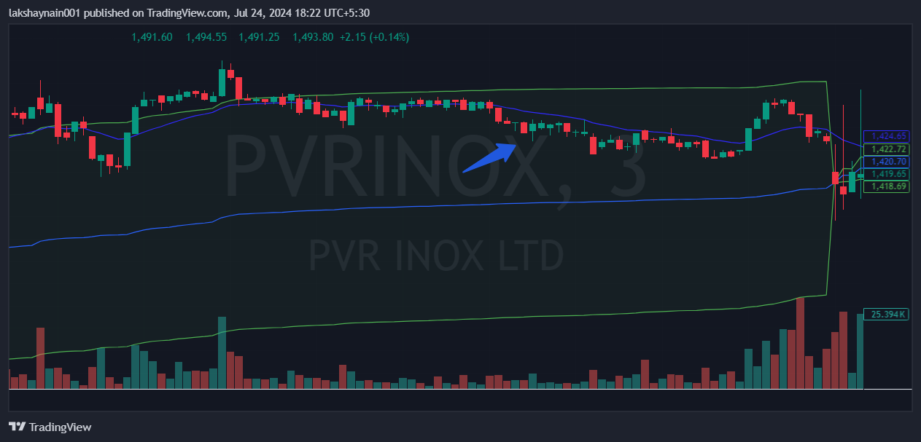
Pvrinox 1420PE
- Price below 20EMA
- Nifty media down

