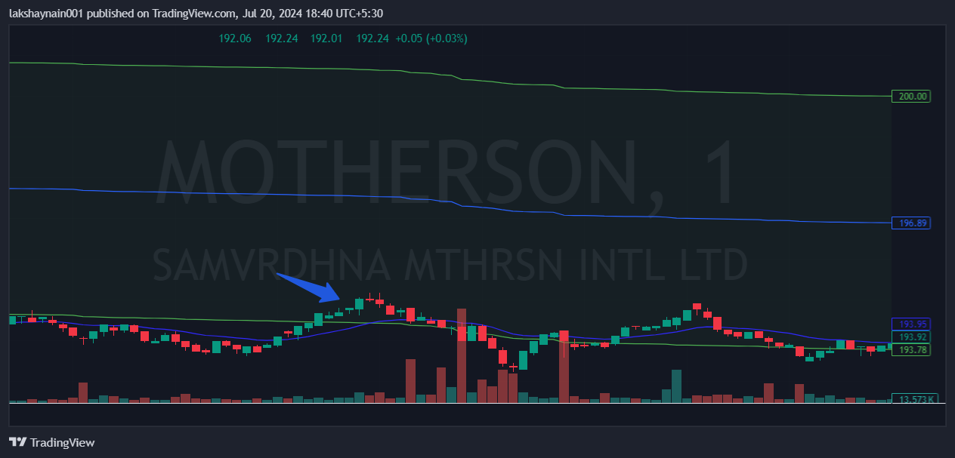
Motherson 195CE
- Price above 20EMA
- Price above vwap lower band
- SL hit below 20EMA

