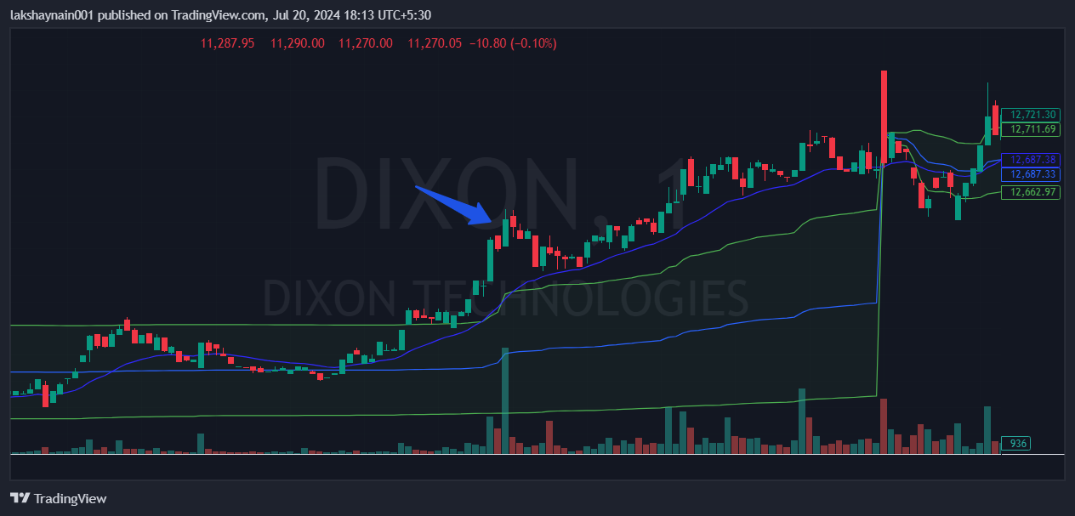
Dixon 13000CE BTST
- Price above 20EMA
- Volume structure supports buying side
- Price sustained above vwap

