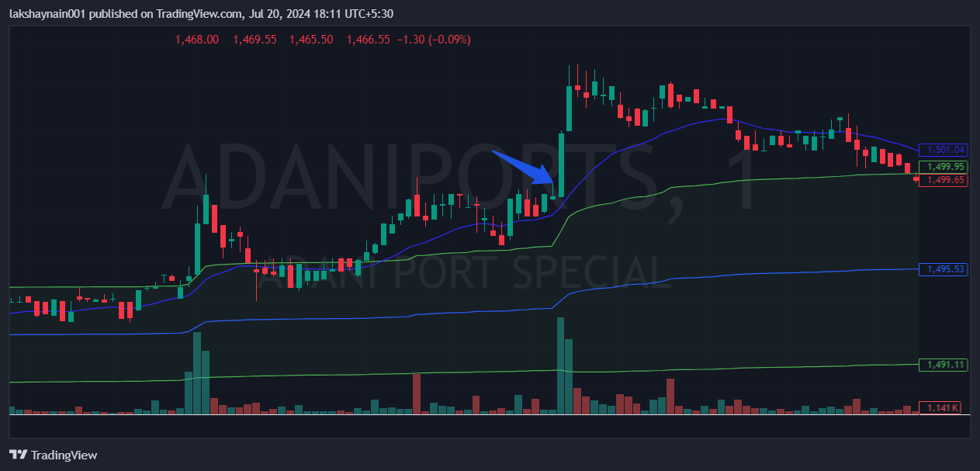
Adaniport 1500CE
- Price broke day high with bullish volumes
- Got thrust from 20EMA
- Above vwap

