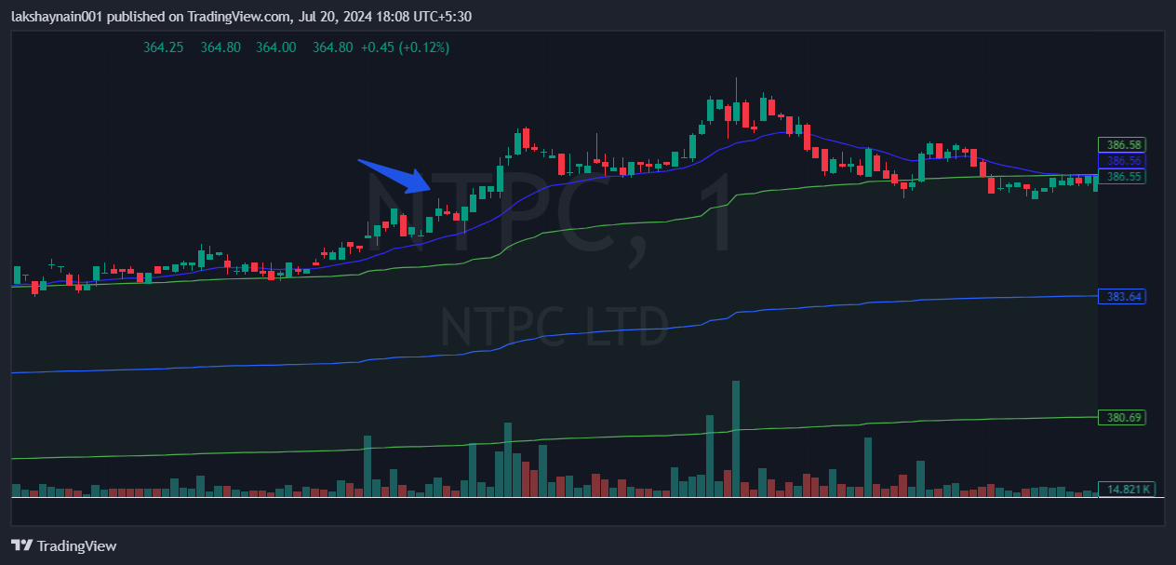
Ntpc 380CE
- Price took strong support at 20EMA
- Price broke day high with good volumes
- Price trading above vwap band

