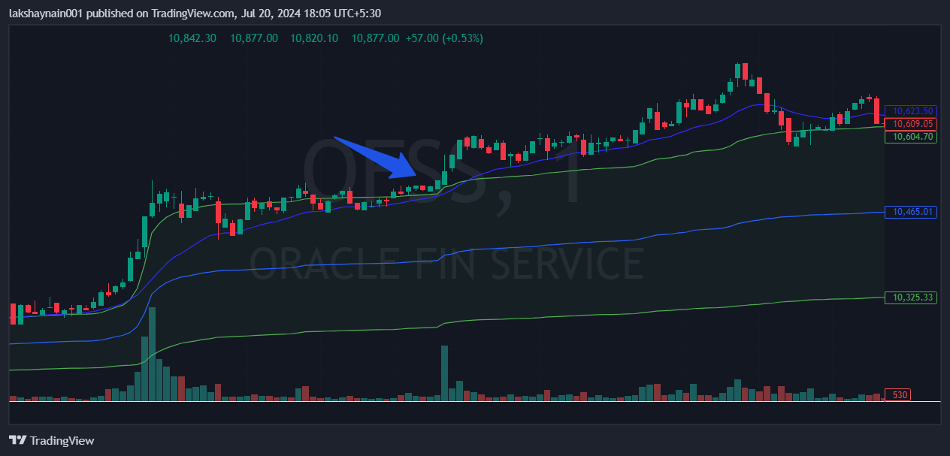
OFSS 10500CE
- Price at day high
- Crossoverr of 20EMA and vwap upper band
- Nifty finserv also supported

