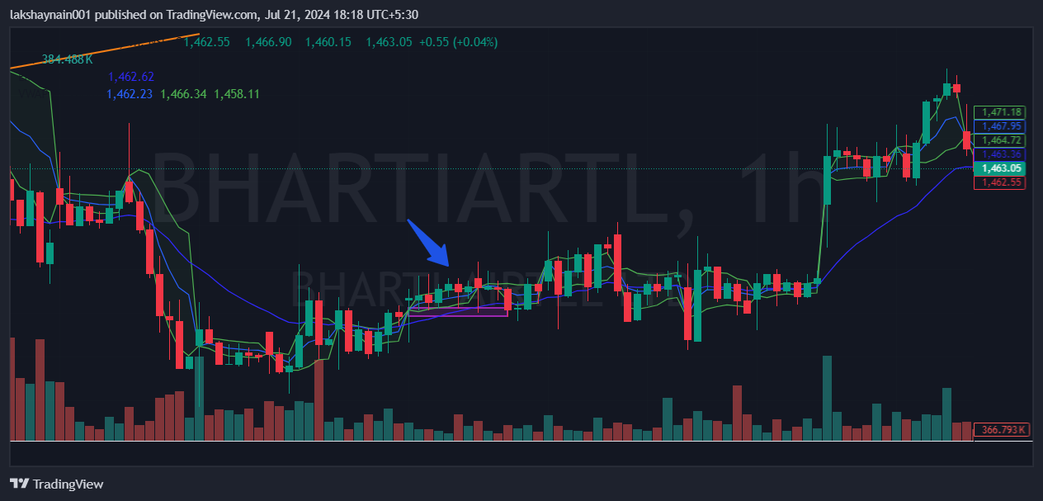
Bharti airtel 1450CE
- Price opened above 20EMA
- Price made a support at the same level
- Price was Above vwap at entry level
- Price taking support at 20EMA + Vwap

