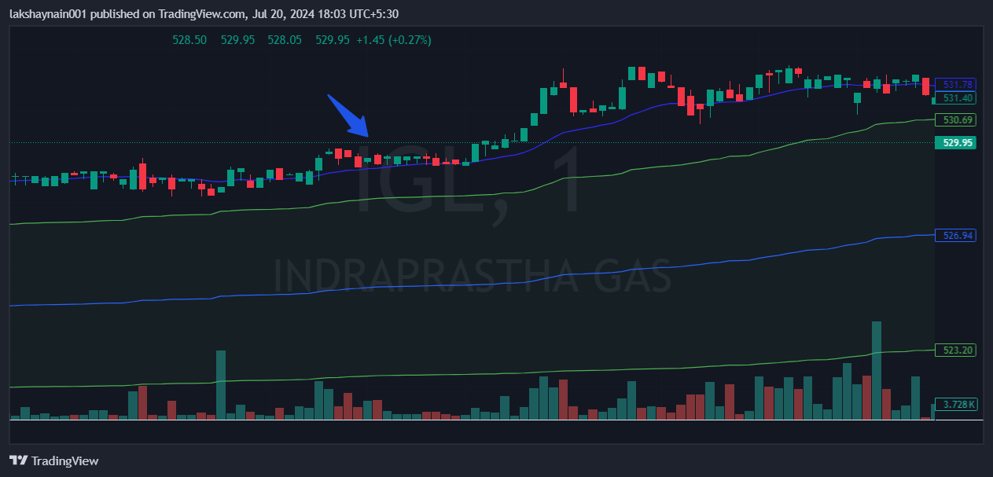
Igl 530CE
- Price at 20EMA support
- Price above vwap

