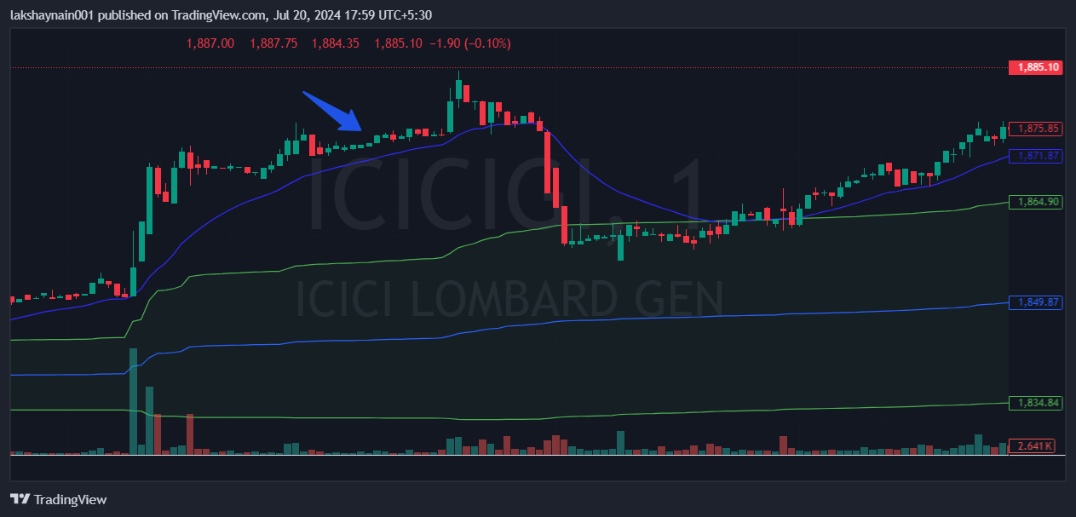
Icicigi 1900CE
- Price near day high
- Above 20EMA with its support
- SL was below 20EMA

