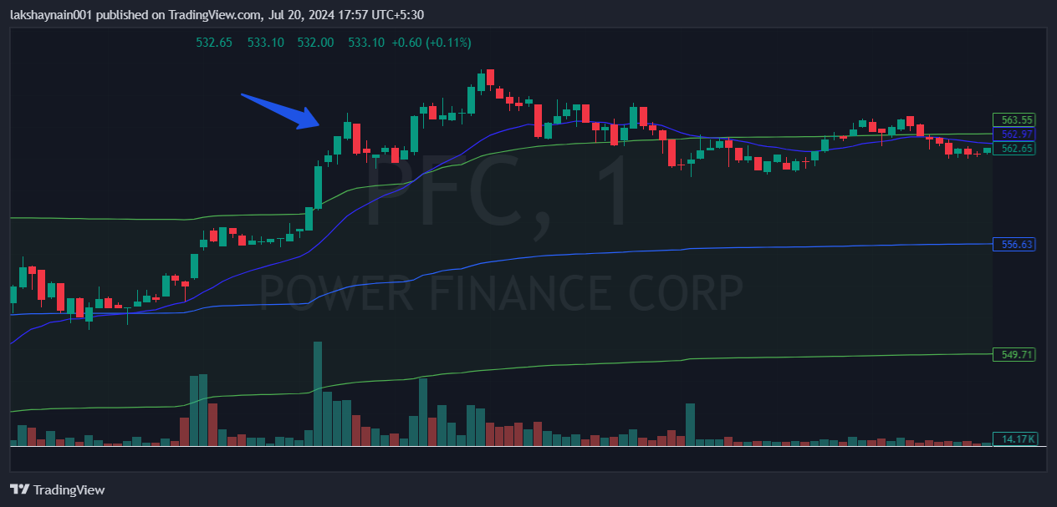PFC 570CE
- Price broke day high with volumes
- Price above vwap and 20EMA

