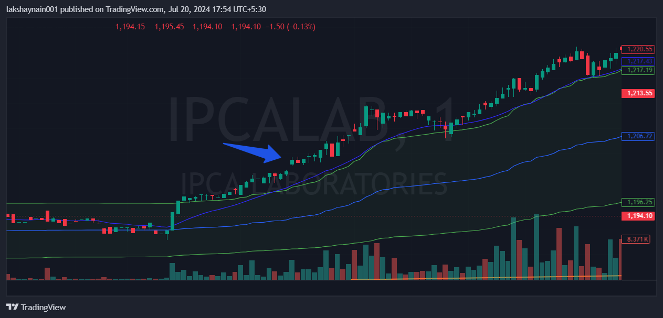
Ipcalab 1200CE
- Price broke day high with gap up
- Nifty pharma also supported
- Price above vwap and 20EMA

