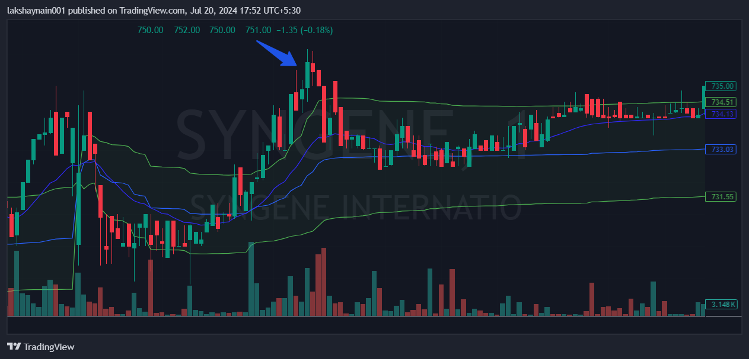
Syngene 740CE
- Price above vwap
- Price above 20EMA
- Broke day’s high

