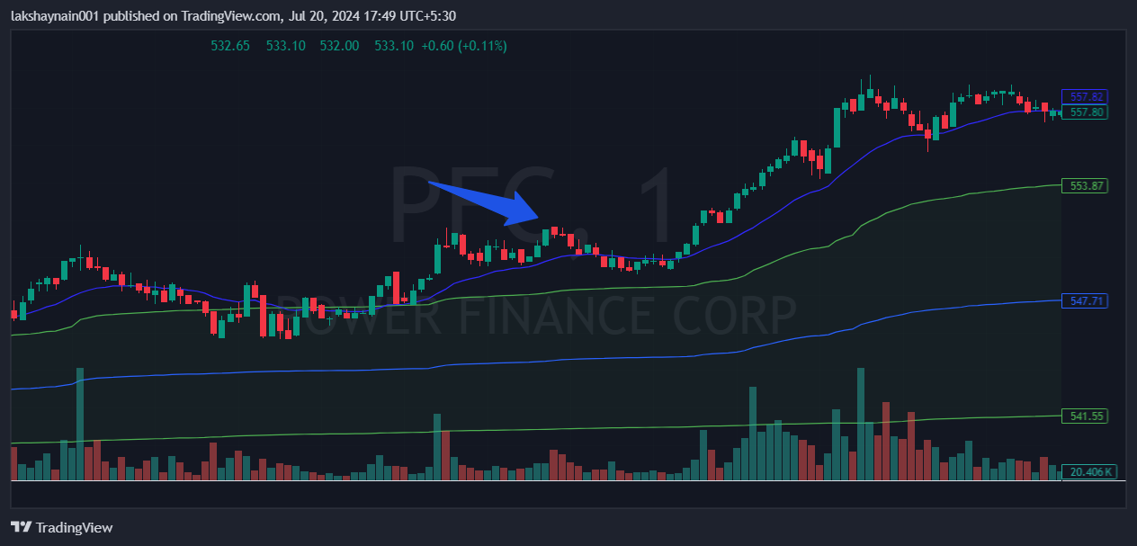
Pfc 550CE
- Price got thrust from 20EMA
- Price above vwap
- Energy sector was also on move
- Price broke day high

