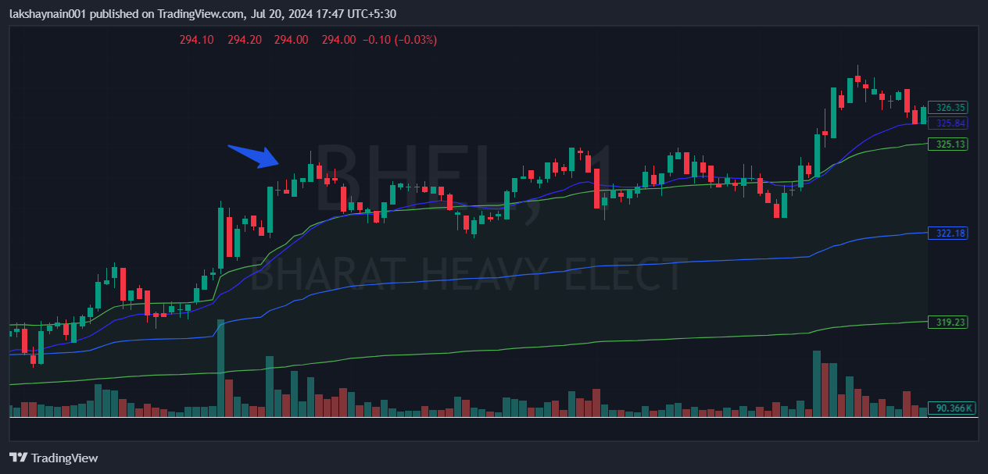
BHEl 330CE
- Price above vwap
- Price broke day high
- Price above vwap and 20EMA

