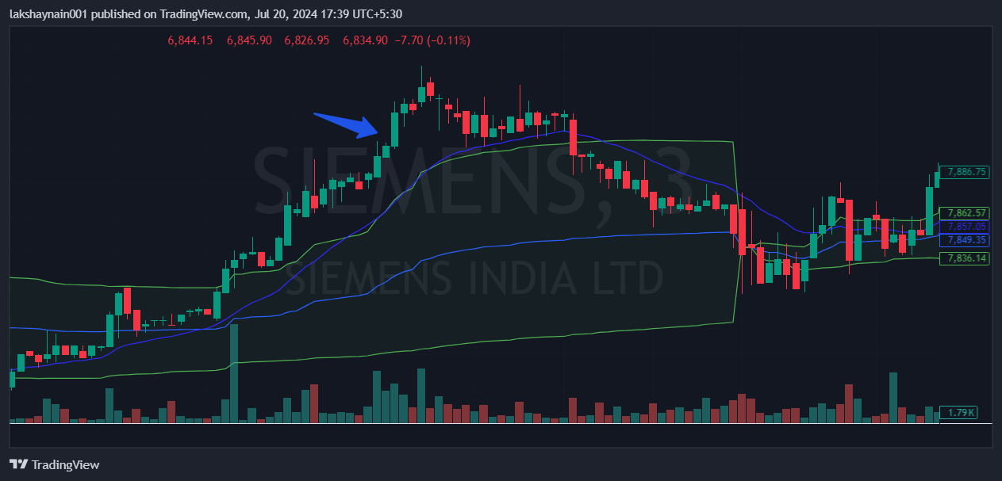
Siemens 8000CE
- Price broke day high
- Buying volume high
- Price trading at above vwap

