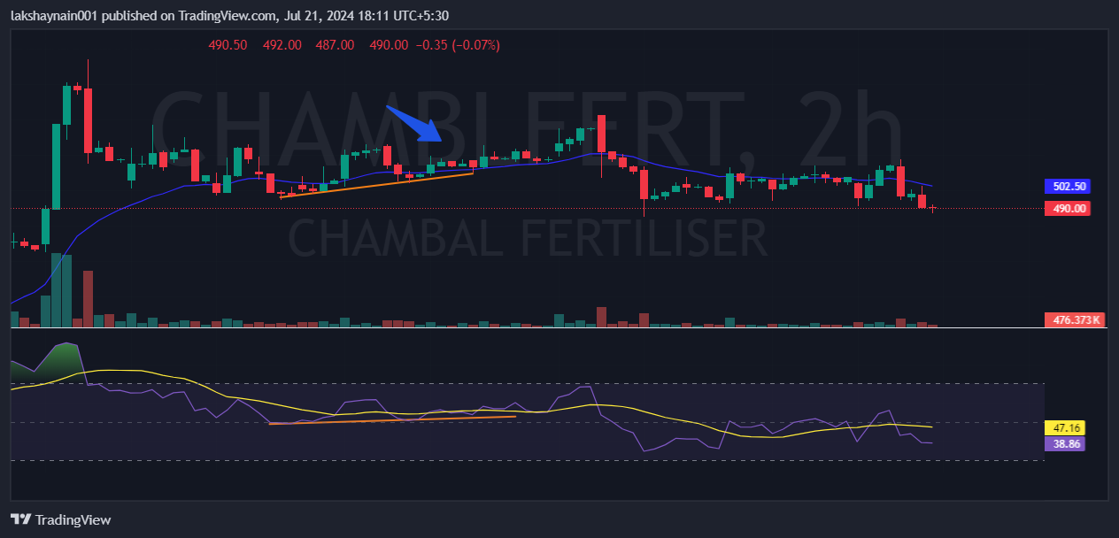
Chambalfetr 530CE
- Medium bullish divergence
- Price taken support and closed above 20EMA
- Fertilizers stock were on move ahead budget

